Geometric Inequalities

Definition
# Source: AI Source: Provided by: [Data Path: Persons Table -> ID Column: 1, Name_En Column: Motasem Essam] -> From: [ChatGPT] on [7/25/2026]
Geometric Inequalities are mathematical statements that compare geometric quantities and establish that one quantity is greater than, less than, greater than or equal to, or less than or equal to another.
They are commonly used to compare:
- lengths
- angles
- areas
- perimeters
- volumes
- distances
- radii
- diameters
- side lengths
- geometric expressions
The main inequality symbols are:
$$>, <, ≥, ≤$$
For example:
$$AB>CD$$
means that segment $AB$is longer than segment $CD$.
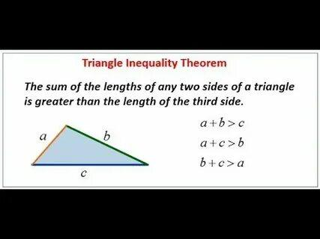
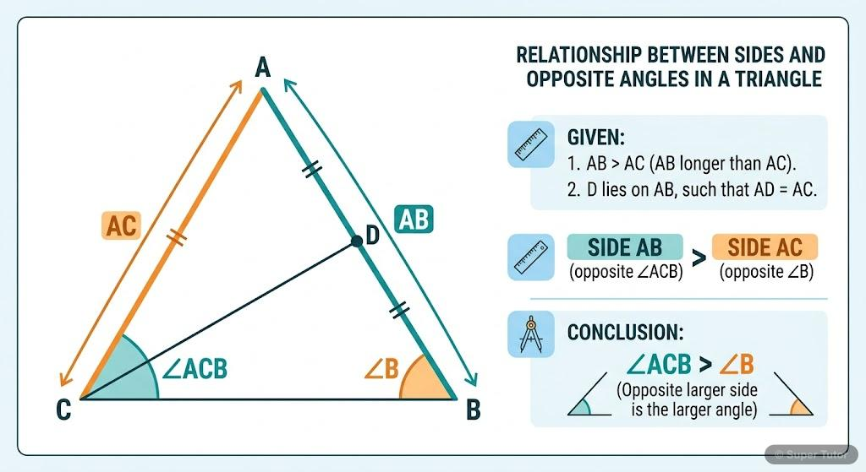
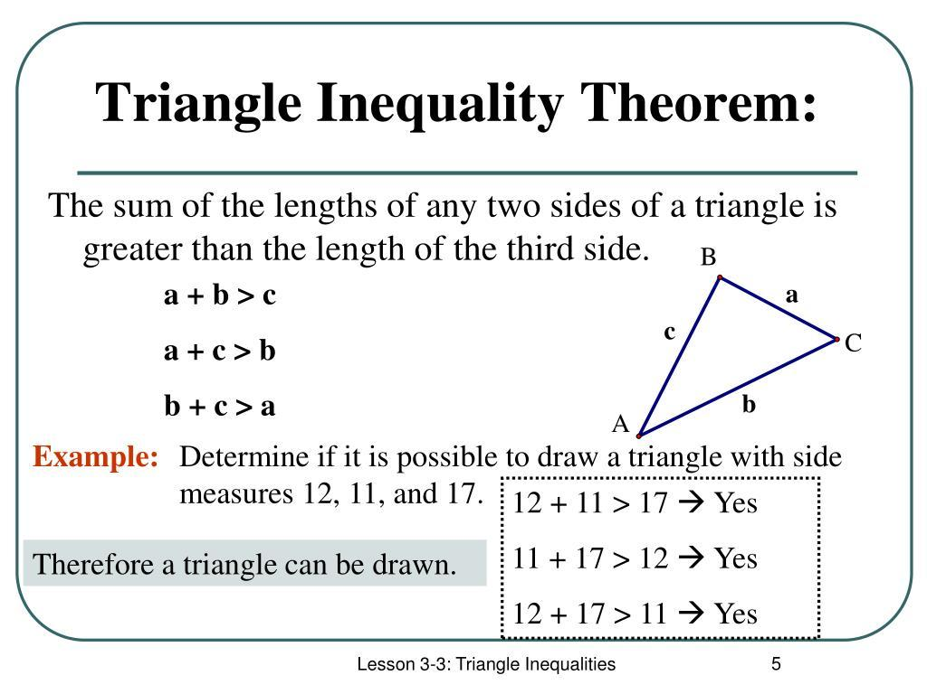
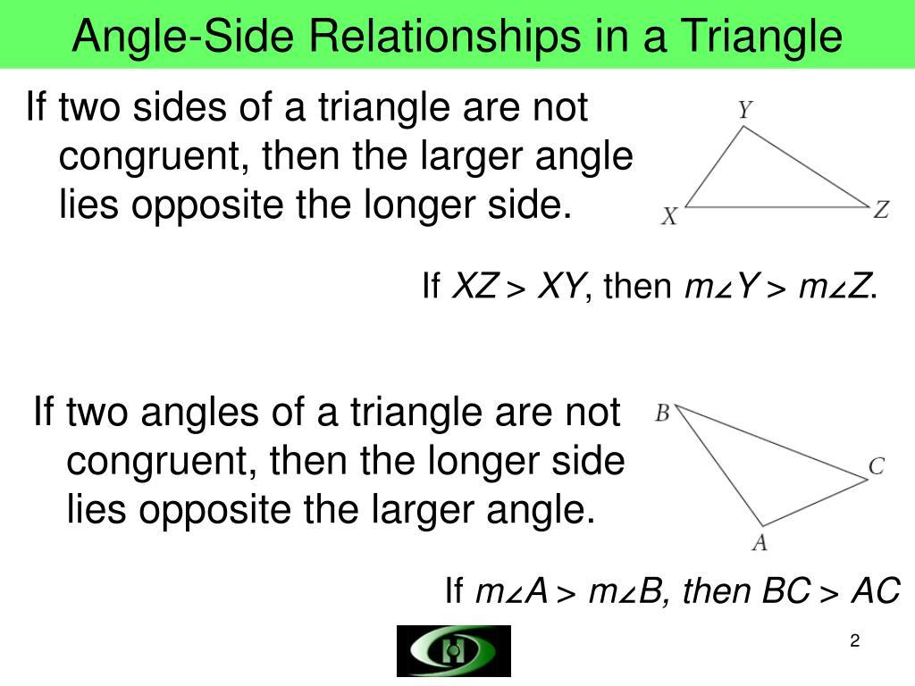
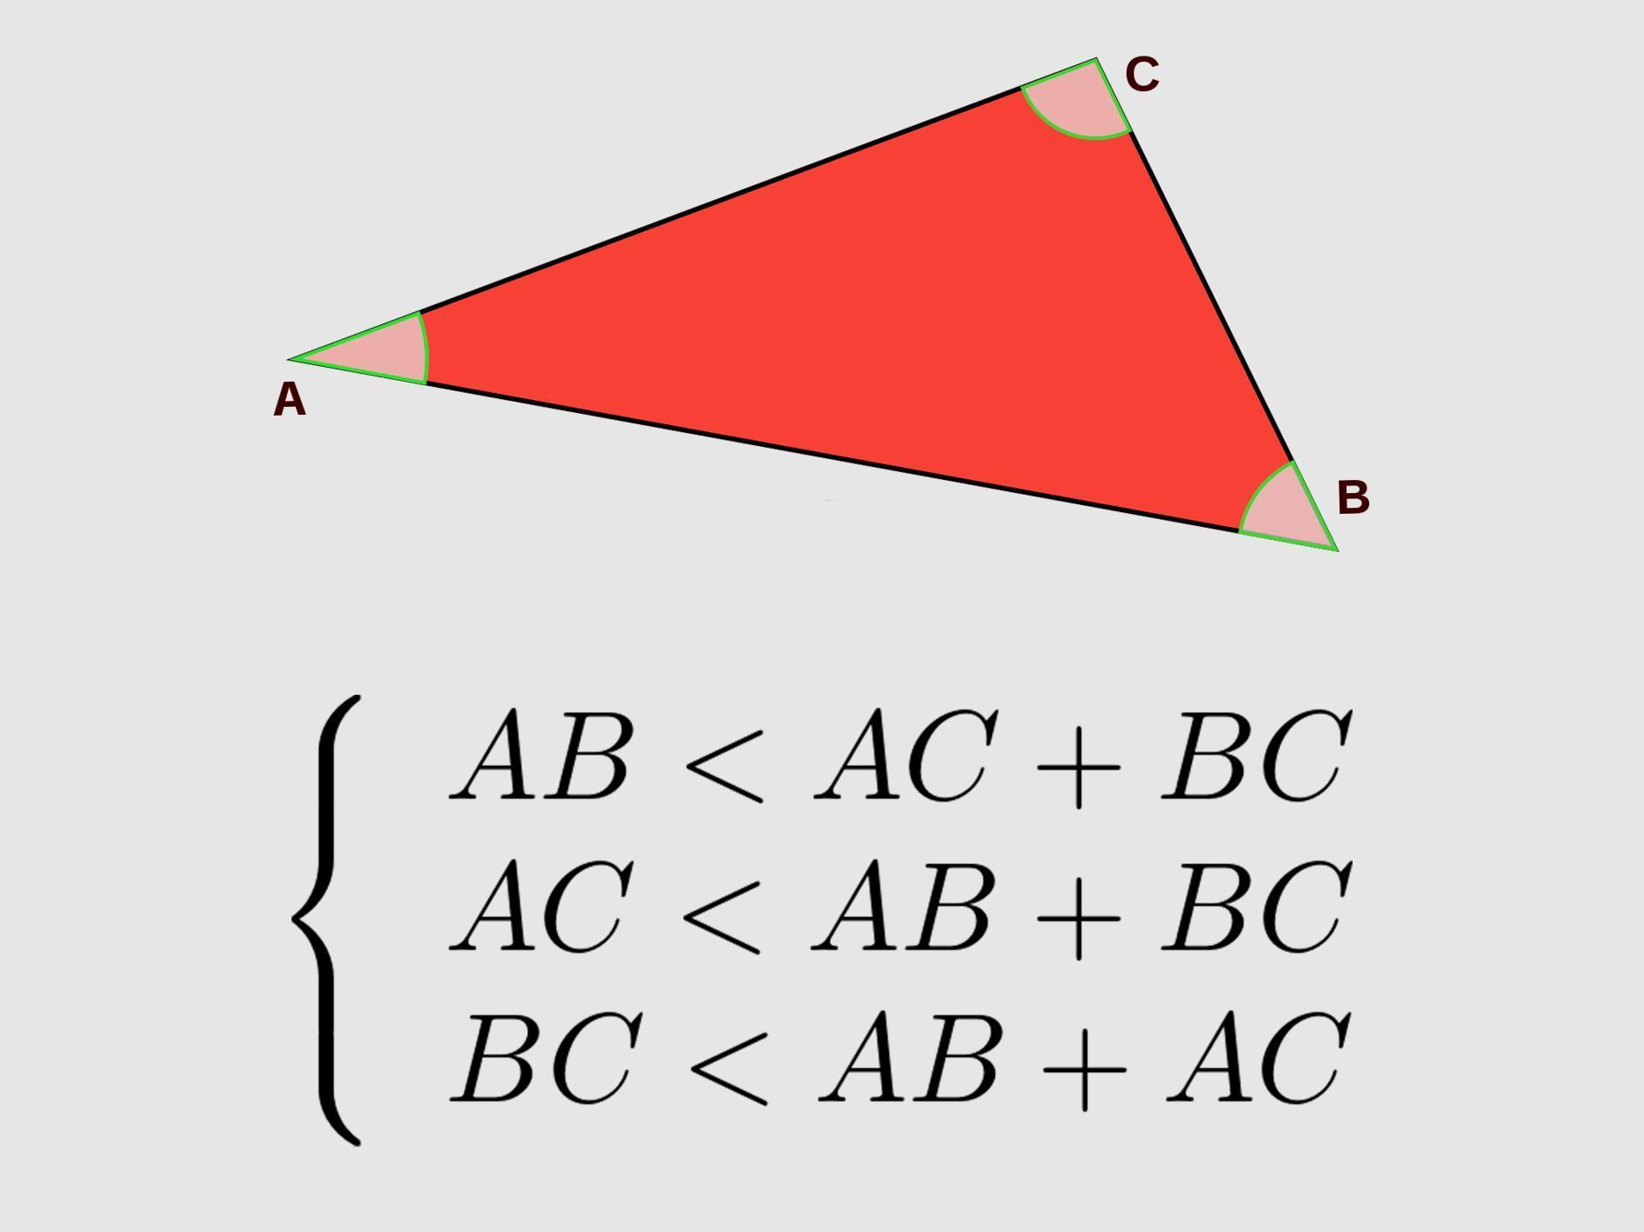
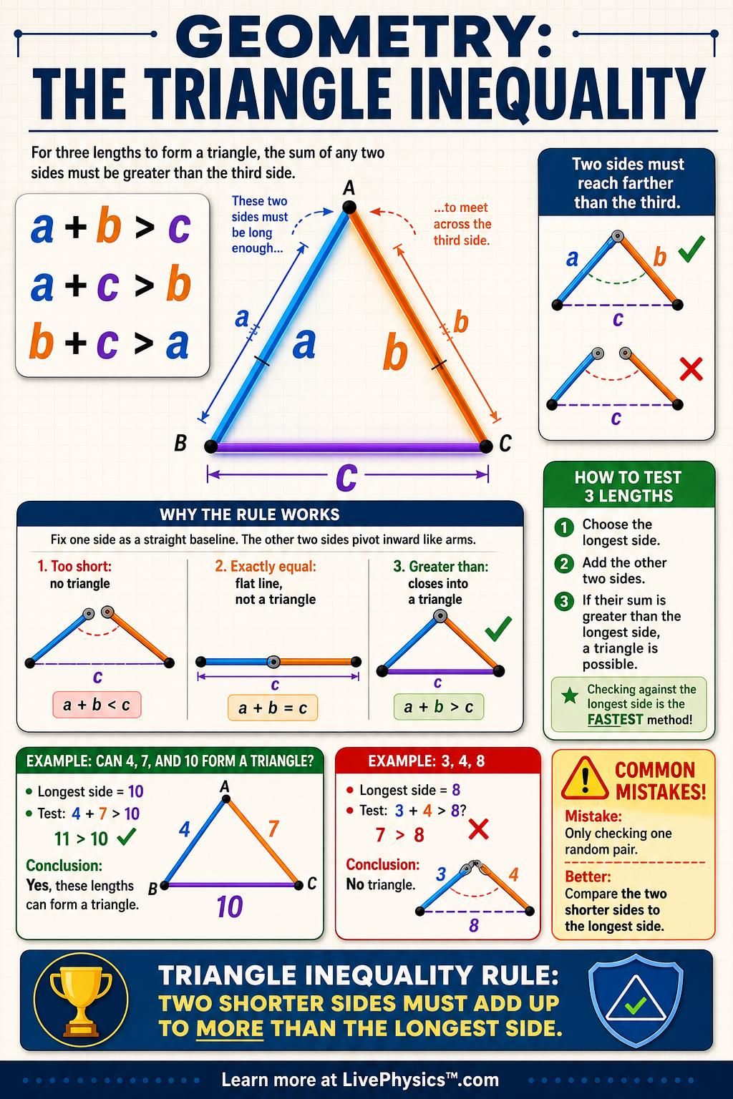

Simple Definition
# Source: AI Source: Provided by: [Data Path: Persons Table -> ID Column: 1, Name_En Column: Motasem Essam] -> From: [ChatGPT] on [7/25/2026]
Geometric inequalities compare geometric quantities and determine which quantity is larger, smaller, or equal under specified conditions.
Unlike a geometric equality, which states that two quantities are exactly equal, an inequality establishes an order or bound.
Equality
$$AB=CD$$
Inequality
$$AB>CD$$
Inequality with equality allowed
$$AB≥CD$$

Fundamental Concept
# Source: AI Source: Provided by: [Data Path: Persons Table -> ID Column: 1, Name_En Column: Motasem Essam] -> From: [ChatGPT] on [7/25/2026]
A geometric inequality usually has the form:
$$\boxed{\text{Geometric Conditions}→\text{Comparison}→\text{Inequality}}$$
For example, in a triangle:
$$AB+AC>BC$$
because the sum of any two sides of a triangle is greater than the third side.
This is called the Triangle Inequality.

Main Types of Geometric Inequalities
# Source: AI Source: Provided by: [Data Path: Persons Table -> ID Column: 1, Name_En Column: Motasem Essam] -> From: [ChatGPT] on [7/25/2026]
A practical classification is:
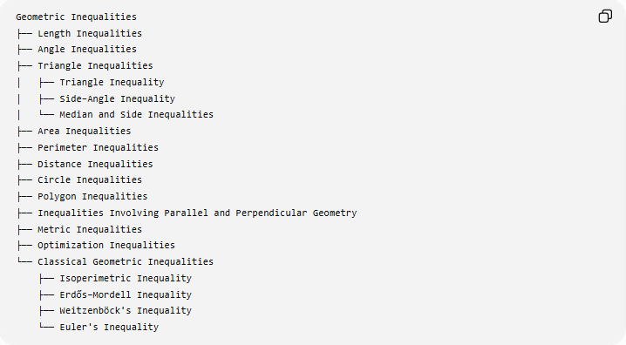
Geometric Inequalities
├── Length Inequalities
├── Angle Inequalities
├── Triangle Inequalities
│ ├── Triangle Inequality
│ ├── Side–Angle Inequality
│ └── Median and Side Inequalities
├── Area Inequalities
├── Perimeter Inequalities
├── Distance Inequalities
├── Circle Inequalities
├── Polygon Inequalities
├── Inequalities Involving Parallel and Perpendicular Geometry
├── Metric Inequalities
├── Optimization Inequalities
└── Classical Geometric Inequalities
├── Isoperimetric Inequality
├── Erdős–Mordell Inequality
├── Weitzenböck's Inequality
└── Euler's Inequality
This is a practical classification, rather than a single universally standardized taxonomy.

Length Inequalities
# Source: AI Source: Provided by: [Data Path: Persons Table -> ID Column: 1, Name_En Column: Motasem Essam] -> From: [ChatGPT] on [7/25/2026]
Definition
Length inequalities compare the lengths of geometric segments, sides, diagonals, radii, or other linear quantities.
Examples:
$$AB>CD \\ PQ≤RS$$
Example
If:
$$AB=8\text{ cm}$$
and
$$CD=5\text{ cm}$$
then:
$$\boxed{AB>CD}$$
because:
$$8>5$$
Important use
Length inequalities frequently arise from:
- triangle inequalities
- shortest-path arguments
- distance comparisons
- side-angle relationships
- triangle congruence/similarity
- geometric optimization.

Angle Inequalities
# Source: AI Source: Provided by: [Data Path: Persons Table -> ID Column: 1, Name_En Column: Motasem Essam] -> From: [ChatGPT] on [7/25/2026]
Definition
Angle inequalities compare the measures of two or more angles.
For example:
$$∠A>∠B$$
means that angle $A$has a greater measure than angle $B$.
Example
If:
$$m∠A={75}^{∘}$$
and:
$$m∠B={40}^{∘}$$
then:
$$\boxed{∠A>∠B}$$
Triangle application
In a triangle, the larger side is opposite the larger angle.
If:
$$AB>AC$$
then the angles opposite these sides satisfy:
$$\boxed{∠C>∠B}$$

Triangle Inequality
# Source: AI Source: Provided by: [Data Path: Persons Table -> ID Column: 1, Name_En Column: Motasem Essam] -> From: [ChatGPT] on [7/25/2026]
Definition
The Triangle Inequality Theorem states that the sum of the lengths of any two sides of a triangle must be greater than the length of the third side.
For sides $a,b,c$:
$$\boxed{a+b>c} \\ \boxed{a+c>b} \\ \boxed{b+c>a}$$
Together:
$$\boxed{∣a-b∣<c<a+b}$$
when $a$and $b$are fixed and $c$is the third side.

Example
Suppose two sides have lengths:
$$5\text{ cm}, 7\text{ cm}$$
What values can the third side $x$have?
The Triangle Inequality gives:
$$∣7-5∣<x<7+5$$
Therefore:
$$\boxed{2<x<12}$$
So $x=8$is possible, while $x=12$is not.

Side–Angle Inequality
# Source: AI Source: Provided by: [Data Path: Persons Table -> ID Column: 1, Name_En Column: Motasem Essam] -> From: [ChatGPT] on [7/25/2026]
Definition
In a triangle, the larger side lies opposite the larger angle, and the larger angle lies opposite the larger side.
For:
$$a>b$$
the opposite angles satisfy:
$$\boxed{A>B}$$
assuming $A$is opposite $a$and $B$is opposite $b$.
Example
Suppose:
$$AB=10, AC=6$$
In $△ABC$:
- $AB$is opposite $∠C$
- $AC$is opposite $∠B$
Since:
$$AB>AC$$
then:
$$\boxed{∠C>∠B}$$

Area Inequalities
# Source: AI Source: Provided by: [Data Path: Persons Table -> ID Column: 1, Name_En Column: Motasem Essam] -> From: [ChatGPT] on [7/25/2026]
Definition
Area inequalities compare the areas of geometric regions.
For example:
$$A_{1}>A_{2}$$
means region 1 has greater area than region 2.
Example
Consider two rectangles with the same perimeter.
One has dimensions:
$$8×2$$
and another:
$$5×5$$
Their areas are:
$$A_{1}=8\left(2\right)=16 \\ A_{2}=5\left(5\right)=25$$
Therefore:
$$\boxed{A_{2}>A_{1}}$$
This illustrates an important geometric optimization principle: among rectangles with the same perimeter, the square has the greatest area.

Perimeter Inequalities
# Source: AI Source: Provided by: [Data Path: Persons Table -> ID Column: 1, Name_En Column: Motasem Essam] -> From: [ChatGPT] on [7/25/2026]
Definition
Perimeter inequalities compare the boundary lengths of geometric figures.
For a polygon:
$$P=s_{1}+s_{2}+⋯+s_{n}$$
An inequality may establish:
$$P_{1}>P_{2}$$
under specified conditions.
Example
Suppose two rectangles have the same area:
$$A=36$$
Rectangle 1:
$$6×6$$
Rectangle 2:
$$4×9$$
Their perimeters are:
$$P_{1}=2\left(6+6\right)=24 \\ P_{2}=2\left(4+9\right)=26$$
Thus:
$$\boxed{P_{1}<P_{2}}$$
For a fixed area, the square has a smaller perimeter than a non-square rectangle.

Distance Inequalities
# Source: AI Source: Provided by: [Data Path: Persons Table -> ID Column: 1, Name_En Column: Motasem Essam] -> From: [ChatGPT] on [7/25/2026]
Definition
A distance inequality compares distances between points or geometric objects.
For points $A,B,C$:
$$AB≤AC+CB$$
This is the point-distance form of the Triangle Inequality.
Example
If:
$$AB=12, AC=5, CB=8$$
then:
$$AB≤AC+CB$$
would require:
$$12≤13$$
which is true.
The equality case occurs when $A,C,B$are collinear and $C$lies between $A$and $B$.

Circle Inequalities
# Source: AI Source: Provided by: [Data Path: Persons Table -> ID Column: 1, Name_En Column: Motasem Essam] -> From: [ChatGPT] on [7/25/2026]
Geometric inequalities also describe relationships involving circles.
For a circle with center $O$and radius $r$:
Inside the circle
$$OP<r$$
On the circle
$$OP=r$$
Outside the circle
$$OP>r$$
Therefore:
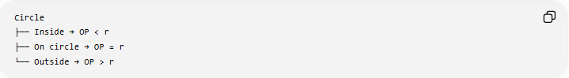
Circle
├── Inside → OP < r
├── On circle → OP = r
└── Outside → OP > r
For a disk:
$$OP≤r$$
describes the entire closed circular region.

Polygon Inequalities
# Source: AI Source: Provided by: [Data Path: Persons Table -> ID Column: 1, Name_En Column: Motasem Essam] -> From: [ChatGPT] on [7/25/2026]
Geometric inequalities also occur in polygons.
For a convex polygon with $n$sides, perimeter and area satisfy various bounds depending on the conditions imposed.
For example, among rectangles with fixed perimeter $P$, the area satisfies:
$$\boxed{A≤\frac{P^{2}}{16}}$$
Equality occurs for a square.
Example
If:
$$P=20$$
then:
$$A≤\frac{{20}^{2}}{16} \\ A≤25$$
The maximum area is:
$$\boxed{25}$$
which occurs for a:
$$5×5$$
square.

Inequalities Involving Perpendicular Geometry
# Source: AI Source: Provided by: [Data Path: Persons Table -> ID Column: 1, Name_En Column: Motasem Essam] -> From: [ChatGPT] on [7/25/2026]
Perpendicular geometry frequently produces shortest-distance inequalities.
For example, the perpendicular segment from a point to a line is the shortest distance from that point to the line.
If $P$is outside line $l$, and $PH⊥l$, then for any other point $Q$on $l$:
$$\boxed{PH≤PQ}$$
with equality only when:
$$Q=H$$
Example
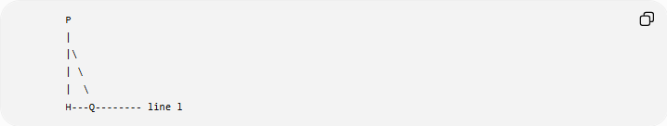
P
|
|\
| \
| \
H---Q-------- line l
Since $PH$is perpendicular to $l$:
$$PH<PQ$$
for every $Q≠H$on $l$.

Metric Inequalities
# Source: AI Source: Provided by: [Data Path: Persons Table -> ID Column: 1, Name_En Column: Motasem Essam] -> From: [ChatGPT] on [7/25/2026]
Definition
Metric inequalities compare measurable geometric quantities such as:
- distances
- lengths
- angles
- areas
- radii
- volumes.
A central example is the Euclidean distance inequality:
$$\boxed{AB≤AC+CB}$$
This says that the direct distance between two points cannot exceed the length of a broken path connecting them.

Isoperimetric Inequality
# Source: AI Source: Provided by: [Data Path: Persons Table -> ID Column: 1, Name_En Column: Motasem Essam] -> From: [ChatGPT] on [7/25/2026]
Definition
The Isoperimetric Inequality relates the area $A$enclosed by a closed plane curve to its perimeter $P$:
$$\boxed{4πA≤P^{2}}$$
Equivalently:
$$\boxed{A≤\frac{P^{2}}{4π}}$$
Equality occurs for a circle.
This establishes a fundamental geometric optimization relationship:
For a fixed perimeter, the circle encloses the greatest possible area.
Example
If:
$$P=20π$$
then:
$$A≤\frac{{\left(20π\right)}^{2}}{4π} \\ A≤100π$$
The equality case is a circle.

Euler's Inequality
# Source: AI Source: Provided by: [Data Path: Persons Table -> ID Column: 1, Name_En Column: Motasem Essam] -> From: [ChatGPT] on [7/25/2026]
In triangle geometry, Euler's Inequality relates the circumradius $R$and inradius $r$:
$$\boxed{R≥2r}$$
Equality occurs for an equilateral triangle.
Thus:
$$\boxed{R≥2r}$$
Example
If a triangle has:
$$r=3$$
then:
$$R≥6$$
So the circumradius cannot be smaller than $6$.

Weitzenböck's Inequality
# Source: AI Source: Provided by: [Data Path: Persons Table -> ID Column: 1, Name_En Column: Motasem Essam] -> From: [ChatGPT] on [7/25/2026]
For a triangle with side lengths $a,b,c$and area $K$:
$$\boxed{a^{2}+b^{2}+c^{2}≥4\sqrt{3}K}$$
Equality occurs for an equilateral triangle.
Example
For an equilateral triangle with side $s$:
$$a=b=c=s$$
and:
$$K=\frac{\sqrt{3}}{4}s^{2}$$
Then:
$$a^{2}+b^{2}+c^{2}=3s^{2}$$
and:
$$4\sqrt{3}K=4\sqrt{3}\left(\frac{\sqrt{3}}{4}s^{2}\right)=3s^{2}$$
so equality holds.

Erdős–Mordell Inequality
# Source: AI Source: Provided by: [Data Path: Persons Table -> ID Column: 1, Name_En Column: Motasem Essam] -> From: [ChatGPT] on [7/25/2026]
For a point $P$inside $△ABC$, let:
$$d_{a},d_{b},d_{c}$$
be its perpendicular distances to sides $BC,CA,AB$, respectively.
The Erdős–Mordell Inequality states:
$$\boxed{PA+PB+PC≥2\left(d_{a}+d_{b}+d_{c}\right)}$$
This is a deeper inequality in triangle geometry.
It compares the sum of distances from an interior point to the vertices with the sum of its perpendicular distances to the three sides.

Geometric Optimization Inequalities
# Source: AI Source: Provided by: [Data Path: Persons Table -> ID Column: 1, Name_En Column: Motasem Essam] -> From: [ChatGPT] on [7/25/2026]
Definition
A geometric optimization inequality establishes a maximum or minimum possible value of a geometric quantity under specified constraints.
Typical questions include:
- What is the maximum area?
- What is the minimum perimeter?
- What is the shortest distance?
- What is the largest possible angle?
- What is the smallest possible length?
Example: Rectangle
For a rectangle with fixed perimeter:
$$P=2\left(L+W\right)$$
the area is:
$$A=LW$$
The maximum occurs when:
$$L=W$$
Therefore, the rectangle with maximum area is a square.

Equality Cases
# Source: AI Source: Provided by: [Data Path: Persons Table -> ID Column: 1, Name_En Column: Motasem Essam] -> From: [ChatGPT] on [7/25/2026]
An important feature of geometric inequalities is the equality case.
An inequality such as:
$$A≤B$$
may become an equality when a special geometric configuration occurs.
For example:
Triangle Inequality
$$a+b≥c$$
Equality would require the three points to be collinear, so they would not form a nondegenerate triangle.
Thus for an actual triangle:
$$\boxed{a+b>c}$$
Euler's Inequality
$$R≥2r$$
Equality occurs for:
$$\boxed{\text{Equilateral triangle}}$$
Isoperimetric Inequality
$$4πA≤P^{2}$$
Equality occurs for:
$$\boxed{\text{Circle}}$$
Equality cases often reveal the special configuration that optimizes the geometry.

Proving Geometric Inequalities
# Source: AI Source: Provided by: [Data Path: Persons Table -> ID Column: 1, Name_En Column: Motasem Essam] -> From: [ChatGPT] on [7/25/2026]
Geometric inequalities can be established using several methods.
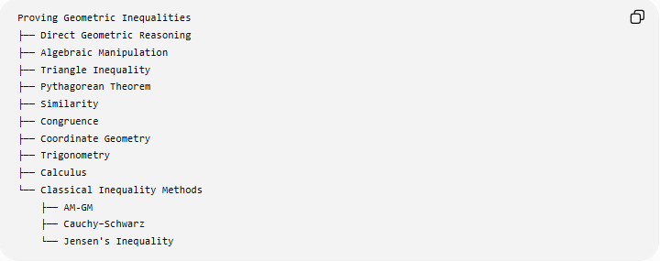
Proving Geometric Inequalities
├── Direct Geometric Reasoning
├── Algebraic Manipulation
├── Triangle Inequality
├── Pythagorean Theorem
├── Similarity
├── Congruence
├── Coordinate Geometry
├── Trigonometry
├── Calculus
└── Classical Inequality Methods
├── AM-GM
├── Cauchy–Schwarz
└── Jensen's Inequality
The appropriate method depends on the problem.

Algebraic Example
# Source: AI Source: Provided by: [Data Path: Persons Table -> ID Column: 1, Name_En Column: Motasem Essam] -> From: [ChatGPT] on [7/25/2026]
Suppose a rectangle has:
$$L+W=10$$
Its area is:
$$A=LW$$
Using:
$${\left(L-W\right)}^{2}≥0$$
we obtain:
$$L^{2}-2LW+W^{2}≥0$$
Therefore:
$${\left(L+W\right)}^{2}≥4LW$$
Since:
$$L+W=10$$
we have:
$$100≥4LW$$
so:
$$\boxed{LW≤25}$$
Thus:
$$\boxed{A≤25}$$
Equality occurs when:
$$L=W=5$$
Therefore the maximum-area rectangle is a square.

Geometric Inequality vs Geometric Equality
# Source: AI Source: Provided by: [Data Path: Persons Table -> ID Column: 1, Name_En Column: Motasem Essam] -> From: [ChatGPT] on [7/25/2026]
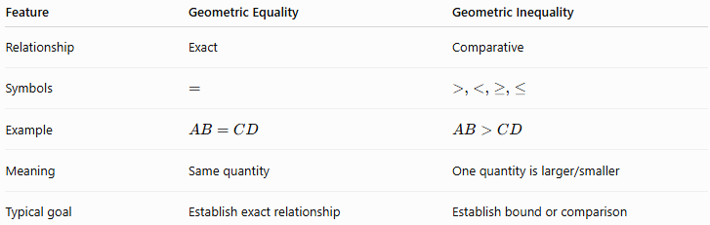
Feature | Geometric Equality | Geometric Inequality
Relationship | Exact | Comparative
Symbols | $$=$$ | $$>,<,≥,≤$$
Example | $$AB=CD$$ | $$AB>CD$$
Meaning | Same quantity | One quantity is larger/smaller
Typical goal | Establish exact relationship | Establish bound or comparison
For example:
$$AB=AC$$
is an equality.
But:
$$AB>AC$$
is an inequality.

Geometric Inequality vs Measurement
# Source: AI Source: Provided by: [Data Path: Persons Table -> ID Column: 1, Name_En Column: Motasem Essam] -> From: [ChatGPT] on [7/25/2026]
A measurement may show:
$$AB≈7.2\text{ cm}$$
and:
$$CD≈5.1\text{ cm}$$
suggesting:
$$AB>CD$$
However, a mathematical proof establishes the relationship exactly.
For example, if it is proven that:
$$AB^{2}>CD^{2}$$
and both lengths are positive, then:
$$\boxed{AB>CD}$$
So measurements can help discover or test an inequality, while deductive reasoning can establish it rigorously.

Important Triangle Inequality Relationships
# Source: AI Source: Provided by: [Data Path: Persons Table -> ID Column: 1, Name_En Column: Motasem Essam] -> From: [ChatGPT] on [7/25/2026]
Several fundamental comparisons occur in triangles.
Sum of two sides
$$\boxed{a+b>c}$$
Difference of two sides
$$\boxed{∣a-b∣<c}$$
Side-angle relationship
$$a>b ⟺ A>B$$
where $A$and $B$are opposite $a$and $b$.
Largest side
The largest side is opposite the largest angle.
Smallest side
The smallest side is opposite the smallest angle.

Important Geometric Inequalities Summary
# Source: AI Source: Provided by: [Data Path: Persons Table -> ID Column: 1, Name_En Column: Motasem Essam] -> From: [ChatGPT] on [7/25/2026]
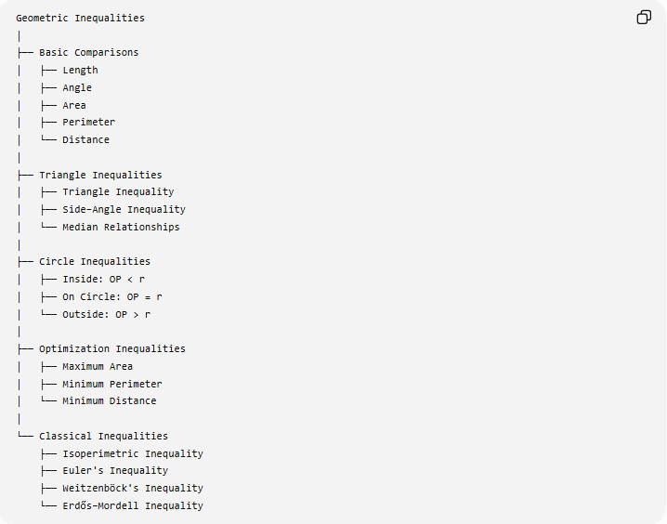
Geometric Inequalities
│
├── Basic Comparisons
│ ├── Length
│ ├── Angle
│ ├── Area
│ ├── Perimeter
│ └── Distance
│
├── Triangle Inequalities
│ ├── Triangle Inequality
│ ├── Side–Angle Inequality
│ └── Median Relationships
│
├── Circle Inequalities
│ ├── Inside: OP < r
│ ├── On Circle: OP = r
│ └── Outside: OP > r
│
├── Optimization Inequalities
│ ├── Maximum Area
│ ├── Minimum Perimeter
│ └── Minimum Distance
│
└── Classical Inequalities
├── Isoperimetric Inequality
├── Euler's Inequality
├── Weitzenböck's Inequality
└── Erdős–Mordell Inequality

Key Points
# Source: AI Source: Provided by: [Data Path: Persons Table -> ID Column: 1, Name_En Column: Motasem Essam] -> From: [ChatGPT] on [7/25/2026]
- Geometric inequalities compare geometric quantities.
- The principal symbols are:
$$>, <, ≥, ≤$$
- The Triangle Inequality requires:
$$\boxed{a+b>c}$$
for every pair of sides.
- In a triangle:
$$\boxed{\text{larger side}↔\text{larger opposite angle}}$$
- A perpendicular segment gives the shortest distance from a point to a line.
- Circle position can be expressed using:
$$OP<r, OP=r, OP>r$$
- Many geometric inequalities establish maximum or minimum values.
- Equality cases are especially important because they identify special configurations such as:
  - equilateral triangles
  - squares
  - circles.
- Important classical examples include:
$$\boxed{R≥2r} \\ \boxed{a^{2}+b^{2}+c^{2}≥4\sqrt{3}K} \\ \boxed{4πA≤P^{2}}$$

Conclusion
# Source: AI Source: Provided by: [Data Path: Persons Table -> ID Column: 1, Name_En Column: Motasem Essam] -> From: [ChatGPT] on [7/25/2026]
Geometric Inequalities form a major part of geometry concerned with comparison, bounds, and optimization rather than only exact equality.
They allow us to establish statements such as:
$$\boxed{\text{one length is greater than another}} \\ \boxed{\text{one area cannot exceed a certain value}} \\ \boxed{\text{a distance is at least a certain minimum}}$$
and
$$\boxed{\text{a geometric quantity is maximized or minimized by a special figure}}$$
The most fundamental example is the Triangle Inequality:
$$\boxed{a+b>c}$$
while more advanced geometric inequalities include the Isoperimetric Inequality, Euler's Inequality, Weitzenböck's Inequality, and Erdős–Mordell Inequality.

